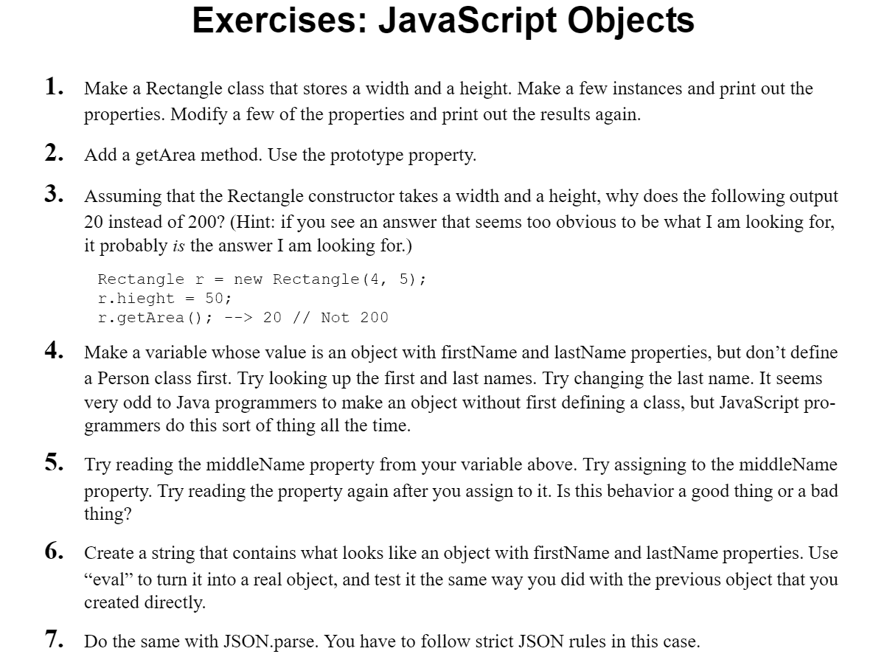

1.

class Recatangle{

    constructor(width,height){

        this.width=width;

        this.height=height;

    }

};

let rect= new Recatangle(10,20);

console.log("Values",rect);

rect.width=15;

console.log("Values",rect);

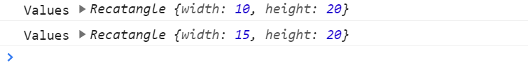

2.

class Recatangle{

    constructor(width,height){

        this.width=width;

        this.height=height;

    }

};

Recatangle.prototype.area=function(){

    return this.height\*this.width;

}

let rect2=new Recatangle(50,10);

console.log(rect2.area());



3.

let r = new Recatangle(4, 5);

r.height = 50; //height & hieght error

console.log(r.area());

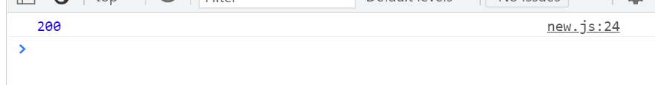

4.

let personOne = {

    firstName: "Shiva",

    lastName: "Mittal"

};

console.log(`Name: ${personOne.firstName} ${personOne.lastName}`);

personOne.lastName = "Cool";

console.log(`Changed Name: ${personOne.firstName} ${personOne.lastName}`);

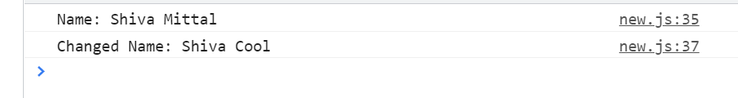

5.

console.log(`Middle name (before defining): ${personOne.middleName}`);

personOne.middleName = "BOSS";

console.log(`Middle name (after defining): ${personOne.middleName}`);

// GOOD BEHAVIOUR

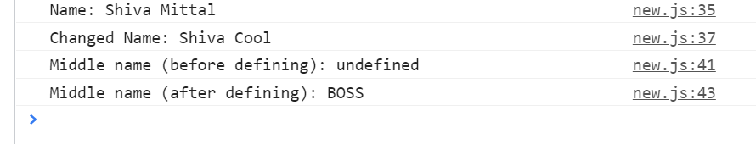

6.

let person = "{firstName:'SHIVA',lastName:'MITTAL'}";

console.log(person);

console.log(eval('(' +person+ ')'));

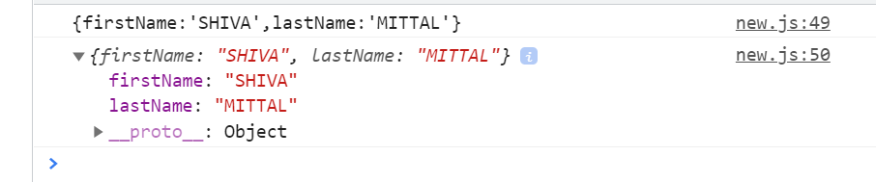

7.

let person = JSON.parse('{"firstName":"SHIVA","lastName":"MITTAL"}');

console.log(person);

